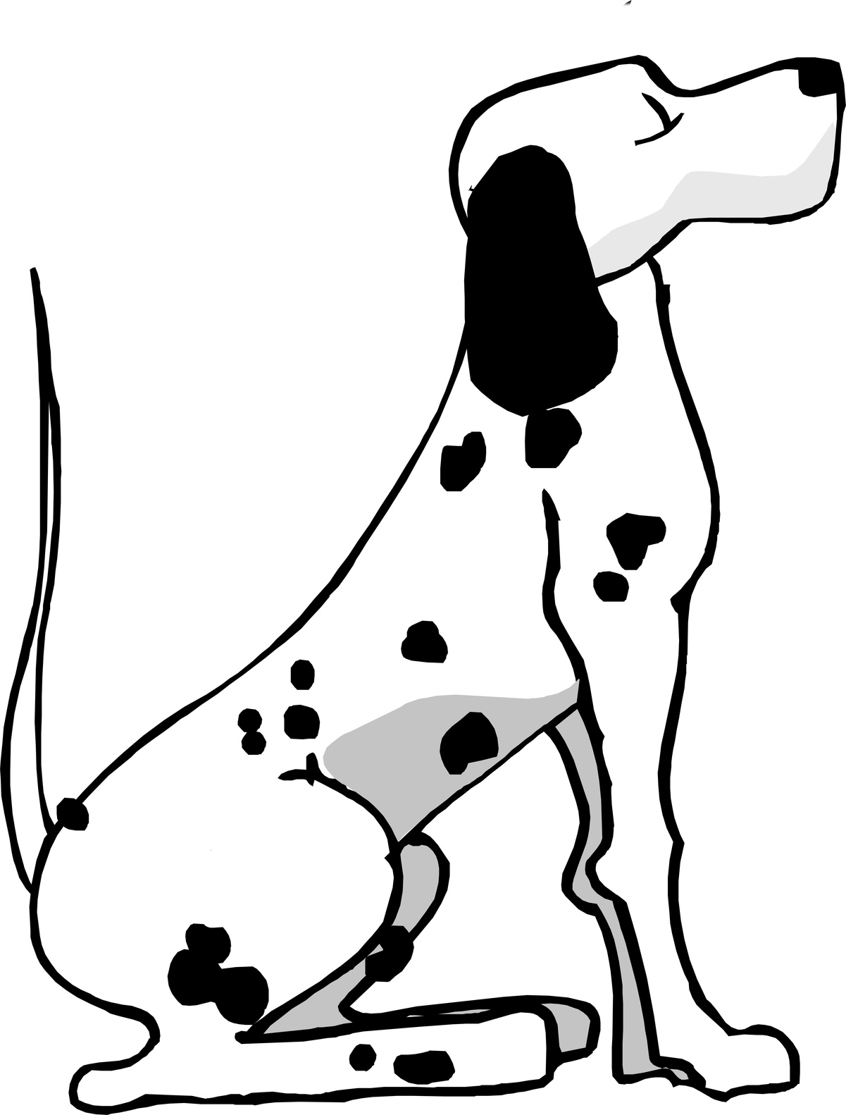 PRIORY FARM DOG BOARDING
Sally Billing BHSII HT
Priory Farm, Andwell, Hook, Nr Basingstoke, Hampshire, RG27 9PA
07810 308704 Sallybilling@googlemail.com www.sallybilling.co.uk
All dogs must be up to date with all vaccinations including kennel cough 14 days prior to arrival.
Owners supply beds, any toys, feed and water bowls, food, and treats.
We reserve the right to seek advice from a vet when necessary if owners cannot be contacted.
PRICES
£16.00 per dog per week day.
£18.00 per dog per weekend days.
£36.00 per dog per bank holiday days.
£60.00 per dog Christmas day.
The day of arrival and day of departure are charged as whole days.
£50.00 is payable at time of booking, this is a deposit to secure your booking and is non refundable in case of cancellations.
Arrival time not before 8:00hrs and collection not after 18:30hrs.
Out of hour’s arrival and collection by special arrangement only.
Please make sure all times are confirmed.
Please be aware that other duties take me off site but the site is never completely unattended.
Our guest dog will be out in the court yard with me at every opportunity.
However we also offer a dog walking service at £5.00 per day.
If you want to take advantage of this service please complete the dog walking form.
Payment Details: Miss Sally Billing Lloyds Bank 00963020 sort code 309332

PRIORY FARM DOG BOARDING

Dog(s) name_______________________________________________________________
Owner’s name_____________________________________________________________
I hereby confirm that I am the owner of the above named dog(s) and authorise Sally Billing to look after and act as guardian during my absence and to take action which she considers suitable in order to protect and keep in good health the above named dog(s). I do further confirm that I will be responsible for any costs which might be incurred, either veterinary or other as a result of any sickness, accident or damage caused to or by the above named dog(s). Except third party liability, and that I will pay any such costs or expenses on demand. I also understand that no liability will attach to Sally Billing. I hereby also give Sally Billing permission to transport my dog(s) to any Veterinary surgery incase of any injury or ill health etc and understand that Sally assumes no responsibility for the loss or any injury to the dog(s) or caused by the dog(s) and is released from all liability related to transportation, treatment and the expense.
I therefore give authorisation for any veterinary treatment required and will be responsible for payments and will settle any accounts upon my return.
Date_________________________________________________________________________

Owner’s signature_________________________________________________________

Dogs Name_________________________________________________________________________
Breed________________________________________________________________________________
Year of birth________________________________________________________________________
Microchip number_________________________________________________________________
Owners Name_____________________________________________________________________
Address_____________________________________________________________________________
______________________________________________________________________________________
______________________________________________________________________________________
______________________________________________________________________________________
Telephone No______________________________________________________________________
Mobile_______________________________________________________________________________
Email________________________________________________________________________________
Vets Name_________________________________________________________________________
Telephone no_______________________________________________________________________
Emergency contact (this should be someone who can make a decision about surgery or euthanasia)
Name________________________________________________________________________________
Telephone no_______________________________________________________________________
Is your dog up to date with flea, worm control and vaccinations including kennel cough________________________________________________________________________________
Neutered____________________________________________________________________________
Any medical history________________________________________________________________

Can your dog be aggressive towards people, other dogs, horses, chickens or any livestock ___________________________________________________________________________
Is your dog house trained_________________________________________________________
Is your dog destructive, i.e. with bedding________________________________________
Can your dog be left for short periods of time___________________________________

Feeding instructions:
______________________________________________________________________________________
______________________________________________________________________________________
______________________________________________________________________________________
______________________________________________________________________________________
______________________________________________________________________________________

Dog walking service.
Please tick each day that you require a walk.
Monday: week 1__________ week 2__________
Tuesday: week 1__________ week 2__________
Wednesday: week 1___________week 2_________
Thursday: week 1__________ week 2__________
Friday: week 1__________ week 2__________
Saturday: week 1__________ week 2__________
Sunday : week 1__________ week 2__________

Additional information.

