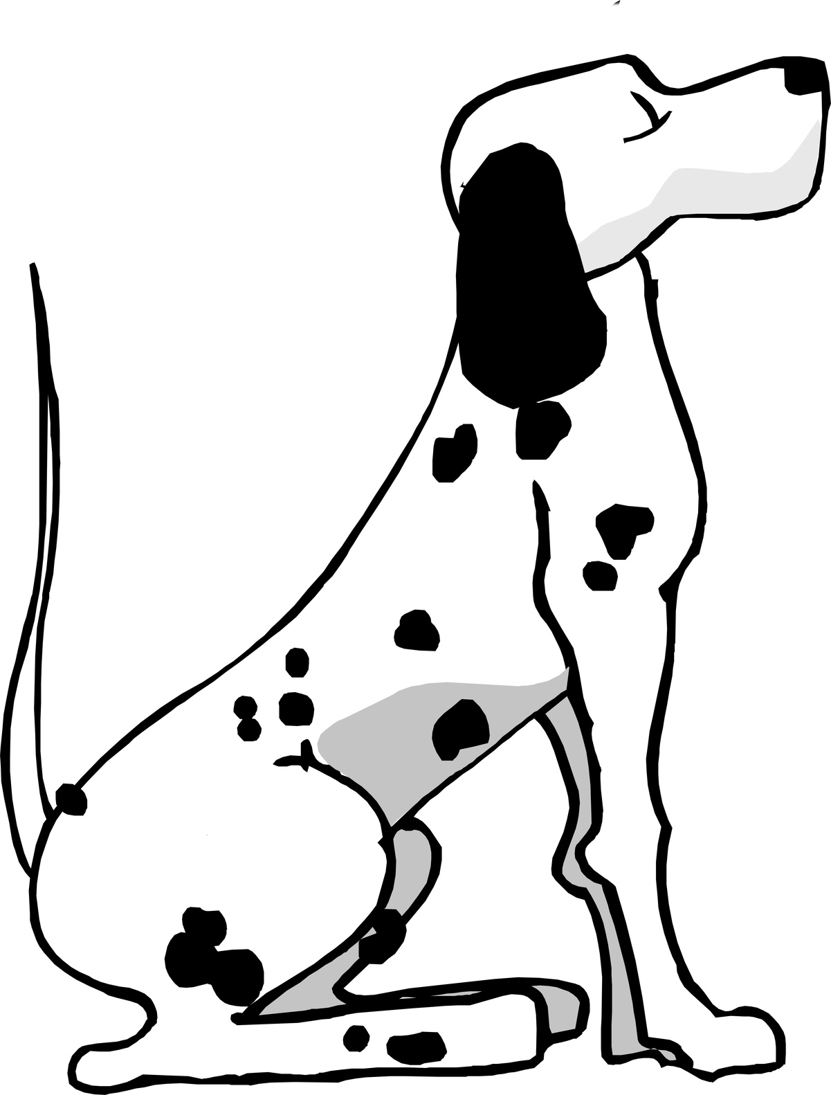 PRIORY FARM DOG BOARDING
All dogs must be up to date with all vaccinations including kennel cough 14 days prior to arrival.
Owners to supply beds, bowls, food, and treats.
We reserve the right to seek advice from a vet when necessary if owners cannot be contacted.
PRICES
£15.00 per dog per week day.
£17.00 per dog per weekend day and bank holidays.
The day of arrival and day of departure is counted as two whole days.
Drop off times not before 8:00hrs
Collection not after 18:30hrs.
Out of hour’s drop off and collection by special arrangement only.
Please make sure all times are confirmed.
Dogs Name_________________________________________
Age__________________________________________________
Microchip details___________________________________
_______________________________________________________
Owners Name______________________________________
Address_____________________________________________
_____________________________________________________________________________________________________________
_______________________________________________________
Telephone No______________________________________
Vet
Name________________________________________________
Telephone no_______________________________________
Emergency contact (this should be someone who can make a decision about surgery or euthanasia)
Name________________________________________________
Telephone no_______________________________________
Food/Notes_____________________________________________________________________________________________________________________________________________________________________________________________________________________________________________________________________
Is your dog up to date with flea and worm control and vaccinations___________________________
Neutered____________________________________________
Any medical history________________________________ _______________________________________________________

Can your dog(s) be aggressive towards people, cats, dogs or livestock______________________________
_______________________________________________________
Is your dog(s) house trained______________________
Can your dog(s) be left for short periods of time
_______________________________________________________
Please be aware that other duties take me off site but the site is never completely unattended.

Date of drop off_____________________________________
Date of collection___________________________________
Payment total_______________________________________
£50.00 is payable at time of booking, this is a deposit to secure your booking and is non refundable in case of cancellations.
Deposit received____________________________________
Balance due on collection__________________________
Date__________________________________________________
Owner’s name______________________________________
Signature____________________________________________

