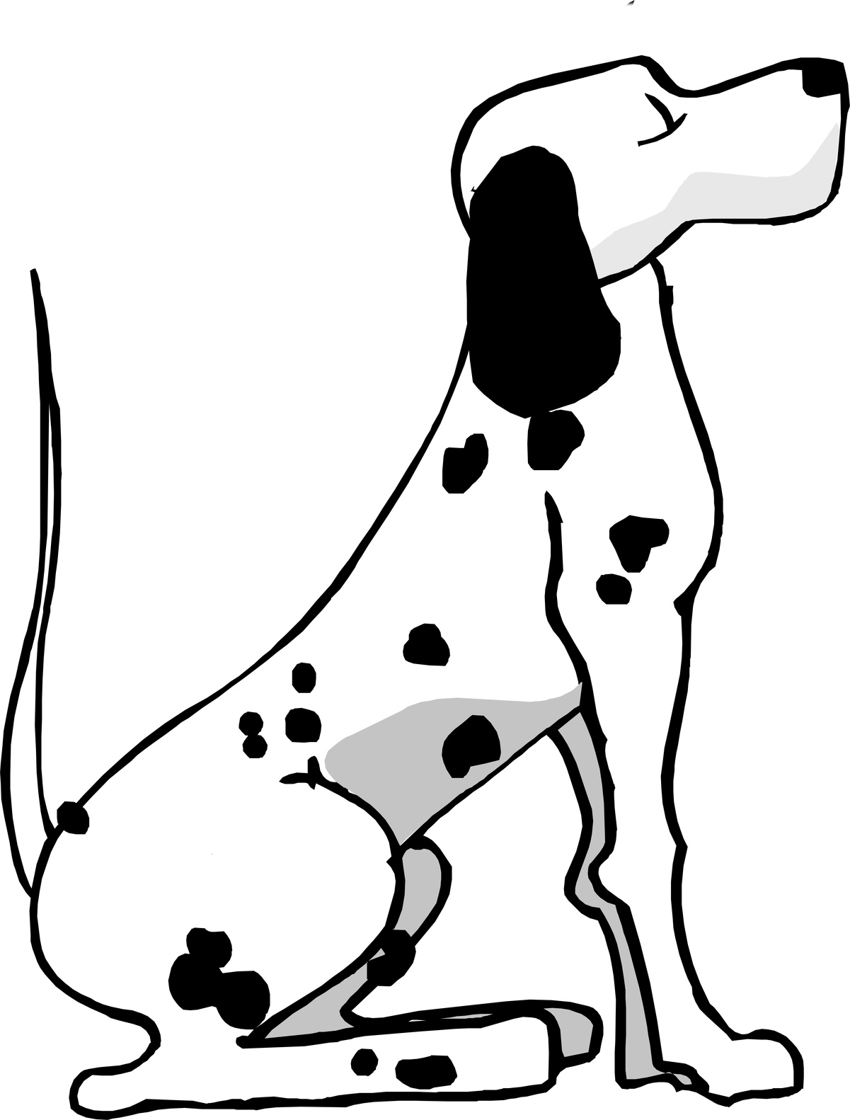 PRIORY FARM DOG BOARDING
Our guest dog will be out in the court yard with me at every opportunity.
We also offer a dog walking service at £5.00 per day.
If you want to take advantage of this service please complete this form.
Dogs name __________________________________________
Date of arrival ______________________________________
Date of departure __________________________________
Please tick each day that you require walking
Week 1 Week 2
Mon __________ Mon ___________
Tue ___________ Tue ____________
Wed __________ Wed ___________
Thurs ________ Thurs _________
Fri ____________ Fri ____________
Sat ___________ Sat ____________
Sun __________ Sun ____________

