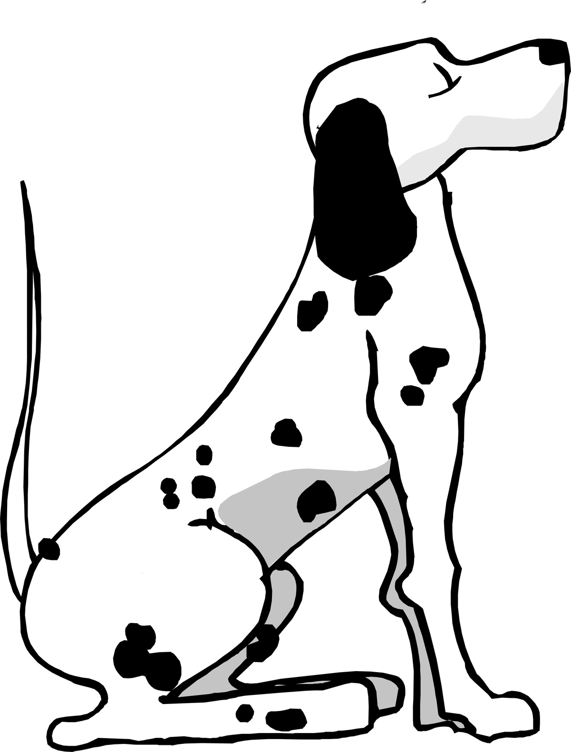 PRIORY FARM DOG BOARDING

Dog(s) name________________________________________
_______________________________________________________
Owner’s name______________________________________
_______________________________________________________
I hereby confirm that I am the owner of the above named dog(s) and authorise Sally Billing to look after and act as guardian during my absence and to take action which she considers suitable in order to protect and keep in good health the above named dog(s). I do further confirm that I will be responsible for any costs which might be incurred, either veterinary or other as a result of any sickness, accident or damage caused to or by the above named dog(s). Except third party liability, and that I will pay any such costs or expenses on demand. I also understand that no liability will attach to Sally Billing. I hereby also give Sally Billing permission to transport my dog(s) to any Veterinary surgery incase of any injury or ill health etc and understand that Sally assumes no responsibility for the loss or any injury to the dog(s) or caused by the dog(s) and is released from all liability related to transportation, treatment and the expense.
I therefore give authorisation for any veterinary treatment required and will be responsible for payments and will settle any accounts upon my return.
Date_________________________________________________

Owner’s signature__________________________________

